# THVD 01

## Chia tập dataset với 80% train, 20% test

Độ chính xác với các giá trị k và p khác nhau:

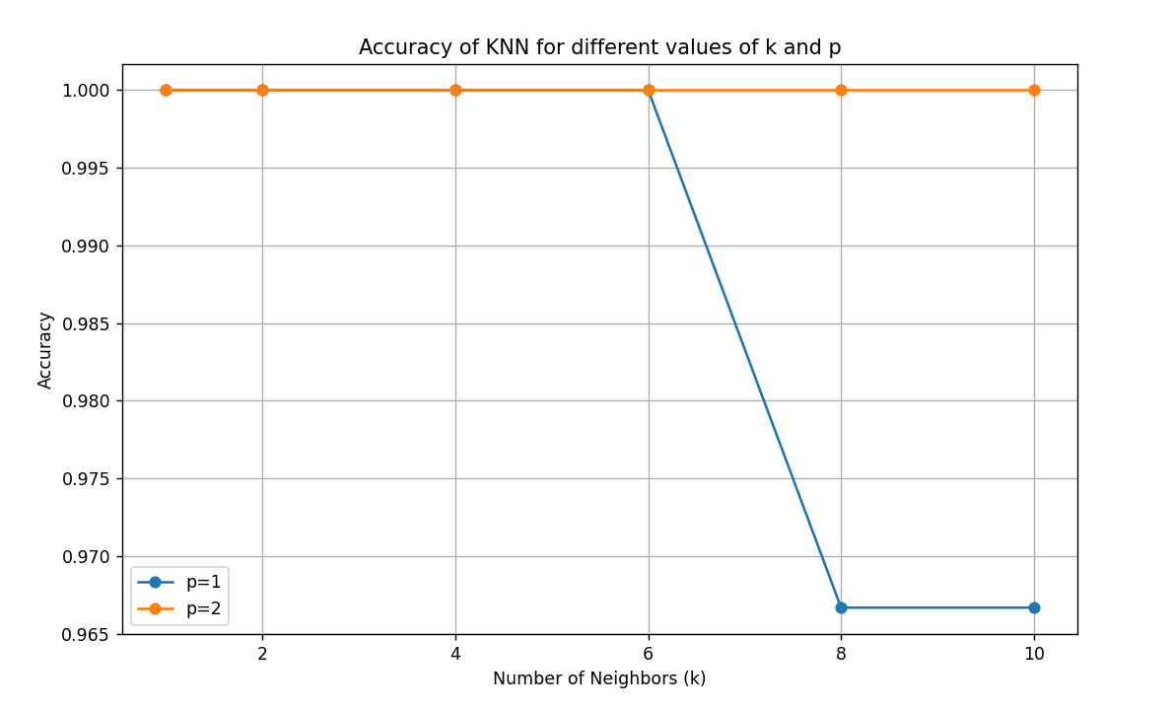

KNN with p=1, k=1

Accuracy: 1.0

Confusion Matrix:

[[10 0 0]

[ 0 9 0]

[ 0 0 11]]

Classification Report:

precision recall f1-score support

0 1.00 1.00 1.00 10

1 1.00 1.00 1.00 9

2 1.00 1.00 1.00 11

accuracy 1.00 30

macro avg 1.00 1.00 1.00 30

weighted avg 1.00 1.00 1.00 30

KNN with p=2, k=1

Accuracy: 1.0

Confusion Matrix:

[[10 0 0]

[ 0 9 0]

[ 0 0 11]]

Classification Report:

precision recall f1-score support

0 1.00 1.00 1.00 10

1 1.00 1.00 1.00 9

2 1.00 1.00 1.00 11

accuracy 1.00 30

macro avg 1.00 1.00 1.00 30

weighted avg 1.00 1.00 1.00 30

KNN with p=1, k=2

Accuracy: 1.0

Confusion Matrix:

[[10 0 0]

[ 0 9 0]

[ 0 0 11]]

Classification Report:

precision recall f1-score support

0 1.00 1.00 1.00 10

1 1.00 1.00 1.00 9

2 1.00 1.00 1.00 11

accuracy 1.00 30

macro avg 1.00 1.00 1.00 30

weighted avg 1.00 1.00 1.00 30

KNN with p=2, k=2

Accuracy: 1.0

Confusion Matrix:

[[10 0 0]

[ 0 9 0]

[ 0 0 11]]

Classification Report:

precision recall f1-score support

0 1.00 1.00 1.00 10

1 1.00 1.00 1.00 9

2 1.00 1.00 1.00 11

accuracy 1.00 30

macro avg 1.00 1.00 1.00 30

weighted avg 1.00 1.00 1.00 30

KNN with p=1, k=4

Accuracy: 1.0

Confusion Matrix:

[[10 0 0]

[ 0 9 0]

[ 0 0 11]]

Classification Report:

precision recall f1-score support

0 1.00 1.00 1.00 10

1 1.00 1.00 1.00 9

2 1.00 1.00 1.00 11

accuracy 1.00 30

macro avg 1.00 1.00 1.00 30

weighted avg 1.00 1.00 1.00 30

KNN with p=2, k=4

Accuracy: 1.0

Confusion Matrix:

[[10 0 0]

[ 0 9 0]

[ 0 0 11]]

Classification Report:

precision recall f1-score support

0 1.00 1.00 1.00 10

1 1.00 1.00 1.00 9

2 1.00 1.00 1.00 11

accuracy 1.00 30

macro avg 1.00 1.00 1.00 30

weighted avg 1.00 1.00 1.00 30

KNN with p=1, k=6

Accuracy: 1.0

Confusion Matrix:

[[10 0 0]

[ 0 9 0]

[ 0 0 11]]

Classification Report:

precision recall f1-score support

0 1.00 1.00 1.00 10

1 1.00 1.00 1.00 9

2 1.00 1.00 1.00 11

accuracy 1.00 30

macro avg 1.00 1.00 1.00 30

weighted avg 1.00 1.00 1.00 30

KNN with p=2, k=6

Accuracy: 1.0

Confusion Matrix:

[[10 0 0]

[ 0 9 0]

[ 0 0 11]]

Classification Report:

precision recall f1-score support

0 1.00 1.00 1.00 10

1 1.00 1.00 1.00 9

2 1.00 1.00 1.00 11

accuracy 1.00 30

macro avg 1.00 1.00 1.00 30

weighted avg 1.00 1.00 1.00 30

KNN with p=1, k=8

Accuracy: 0.9666666666666667

Confusion Matrix:

[[10 0 0]

[ 0 9 0]

[ 0 1 10]]

Classification Report:

precision recall f1-score support

0 1.00 1.00 1.00 10

1 0.90 1.00 0.95 9

2 1.00 0.91 0.95 11

accuracy 0.97 30

macro avg 0.97 0.97 0.97 30

weighted avg 0.97 0.97 0.97 30

KNN with p=2, k=8

Accuracy: 1.0

Confusion Matrix:

[[10 0 0]

[ 0 9 0]

[ 0 0 11]]

Classification Report:

precision recall f1-score support

0 1.00 1.00 1.00 10

1 1.00 1.00 1.00 9

2 1.00 1.00 1.00 11

accuracy 1.00 30

macro avg 1.00 1.00 1.00 30

weighted avg 1.00 1.00 1.00 30

KNN with p=1, k=10

Accuracy: 0.9666666666666667

Confusion Matrix:

[[10 0 0]

[ 0 9 0]

[ 0 1 10]]

Classification Report:

precision recall f1-score support

0 1.00 1.00 1.00 10

1 0.90 1.00 0.95 9

2 1.00 0.91 0.95 11

accuracy 0.97 30

macro avg 0.97 0.97 0.97 30

weighted avg 0.97 0.97 0.97 30

KNN with p=2, k=10

Accuracy: 1.0

Confusion Matrix:

[[10 0 0]

[ 0 9 0]

[ 0 0 11]]

Classification Report:

precision recall f1-score support

0 1.00 1.00 1.00 10

1 1.00 1.00 1.00 9

2 1.00 1.00 1.00 11

accuracy 1.00 30

macro avg 1.00 1.00 1.00 30

weighted avg 1.00 1.00 1.00 30

## Chia tập dataset với 66% train, 33% test

Độ chính xác với các giá trị k và p khác nhau:

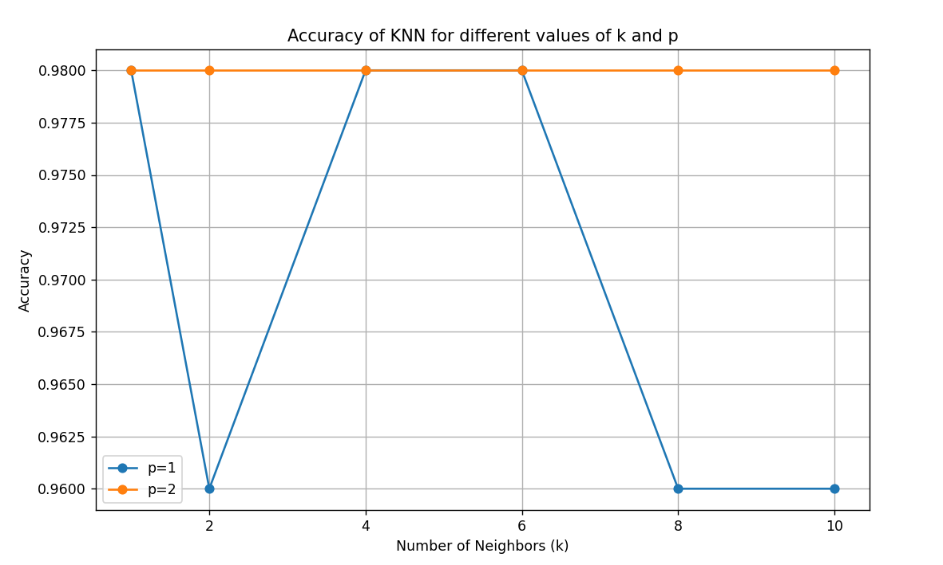

KNN with p=1, k=1

Accuracy: 0.98

Confusion Matrix:

[[19 0 0]

[ 0 15 0]

[ 0 1 15]]

Classification Report:

precision recall f1-score support

0 1.00 1.00 1.00 19

1 0.94 1.00 0.97 15

2 1.00 0.94 0.97 16

accuracy 0.98 50

macro avg 0.98 0.98 0.98 50

weighted avg 0.98 0.98 0.98 50

KNN with p=2, k=1

Accuracy: 0.98

Confusion Matrix:

[[19 0 0]

[ 0 15 0]

[ 0 1 15]]

Classification Report:

precision recall f1-score support

0 1.00 1.00 1.00 19

1 0.94 1.00 0.97 15

2 1.00 0.94 0.97 16

accuracy 0.98 50

macro avg 0.98 0.98 0.98 50

weighted avg 0.98 0.98 0.98 50

KNN with p=1, k=2

Accuracy: 0.96

Confusion Matrix:

[[19 0 0]

[ 0 15 0]

[ 0 2 14]]

Classification Report:

precision recall f1-score support

0 1.00 1.00 1.00 19

1 0.88 1.00 0.94 15

2 1.00 0.88 0.93 16

accuracy 0.96 50

macro avg 0.96 0.96 0.96 50

weighted avg 0.96 0.96 0.96 50

KNN with p=2, k=2

Accuracy: 0.98

Confusion Matrix:

[[19 0 0]

[ 0 15 0]

[ 0 1 15]]

Classification Report:

precision recall f1-score support

0 1.00 1.00 1.00 19

1 0.94 1.00 0.97 15

2 1.00 0.94 0.97 16

accuracy 0.98 50

macro avg 0.98 0.98 0.98 50

weighted avg 0.98 0.98 0.98 50

KNN with p=1, k=4

Accuracy: 0.98

Confusion Matrix:

[[19 0 0]

[ 0 15 0]

[ 0 1 15]]

Classification Report:

precision recall f1-score support

0 1.00 1.00 1.00 19

1 0.94 1.00 0.97 15

2 1.00 0.94 0.97 16

accuracy 0.98 50

macro avg 0.98 0.98 0.98 50

weighted avg 0.98 0.98 0.98 50

KNN with p=2, k=4

Accuracy: 0.98

Confusion Matrix:

[[19 0 0]

[ 0 15 0]

[ 0 1 15]]

Classification Report:

precision recall f1-score support

0 1.00 1.00 1.00 19

1 0.94 1.00 0.97 15

2 1.00 0.94 0.97 16

accuracy 0.98 50

macro avg 0.98 0.98 0.98 50

weighted avg 0.98 0.98 0.98 50

KNN with p=1, k=6

Accuracy: 0.98

Confusion Matrix:

[[19 0 0]

[ 0 15 0]

[ 0 1 15]]

Classification Report:

precision recall f1-score support

0 1.00 1.00 1.00 19

1 0.94 1.00 0.97 15

2 1.00 0.94 0.97 16

accuracy 0.98 50

macro avg 0.98 0.98 0.98 50

weighted avg 0.98 0.98 0.98 50

KNN with p=2, k=6

Accuracy: 0.98

Confusion Matrix:

[[19 0 0]

[ 0 15 0]

[ 0 1 15]]

Classification Report:

precision recall f1-score support

0 1.00 1.00 1.00 19

1 0.94 1.00 0.97 15

2 1.00 0.94 0.97 16

accuracy 0.98 50

macro avg 0.98 0.98 0.98 50

weighted avg 0.98 0.98 0.98 50

KNN with p=1, k=8

Accuracy: 0.96

Confusion Matrix:

[[19 0 0]

[ 0 15 0]

[ 0 2 14]]

Classification Report:

precision recall f1-score support

0 1.00 1.00 1.00 19

1 0.88 1.00 0.94 15

2 1.00 0.88 0.93 16

accuracy 0.96 50

macro avg 0.96 0.96 0.96 50

weighted avg 0.96 0.96 0.96 50

KNN with p=2, k=8

Accuracy: 0.98

Confusion Matrix:

[[19 0 0]

[ 0 15 0]

[ 0 1 15]]

Classification Report:

precision recall f1-score support

0 1.00 1.00 1.00 19

1 0.94 1.00 0.97 15

2 1.00 0.94 0.97 16

accuracy 0.98 50

macro avg 0.98 0.98 0.98 50

weighted avg 0.98 0.98 0.98 50

KNN with p=1, k=10

Accuracy: 0.96

Confusion Matrix:

[[19 0 0]

[ 0 15 0]

[ 0 2 14]]

Classification Report:

precision recall f1-score support

0 1.00 1.00 1.00 19

1 0.88 1.00 0.94 15

2 1.00 0.88 0.93 16

accuracy 0.96 50

macro avg 0.96 0.96 0.96 50

weighted avg 0.96 0.96 0.96 50

KNN with p=2, k=10

Accuracy: 0.98

Confusion Matrix:

[[19 0 0]

[ 0 15 0]

[ 0 1 15]]

Classification Report:

precision recall f1-score support

0 1.00 1.00 1.00 19

1 0.94 1.00 0.97 15

2 1.00 0.94 0.97 16

accuracy 0.98 50

macro avg 0.98 0.98 0.98 50

weighted avg 0.98 0.98 0.98 50

## Các bộ số tối ưu

KNN with p=2, k=10

KNN with p=2, k=8

KNN with p=1, k=6

KNN with p=2, k=1

KNN with p=1, k=1

# THVD 02

## Sử dụng Naive Bayes với 66% train 33% test

GaussianNB

Accuracy: 0.96

Confusion Matrix:

[[19 0 0]

[ 0 14 1]

[ 0 1 15]]

Classification Report:

precision recall f1-score support

0 1.00 1.00 1.00 19

1 0.93 0.93 0.93 15

2 0.94 0.94 0.94 16

accuracy 0.96 50

macro avg 0.96 0.96 0.96 50

weighted avg 0.96 0.96 0.96 50

## Sử dụng Naive Bayes với 80% train 20% test

GaussianNB

Accuracy: 1.0

Confusion Matrix:

[[10 0 0]

[ 0 9 0]

[ 0 0 11]]

Classification Report:

precision recall f1-score support

0 1.00 1.00 1.00 10

1 1.00 1.00 1.00 9

2 1.00 1.00 1.00 11

accuracy 1.00 30

macro avg 1.00 1.00 1.00 30

weighted avg 1.00 1.00 1.00 30

Từ kết quả chạy Bayes, ta thấy sử dụng giải thuật Bayes trên tập Iris cho kết quả tốt hơn.